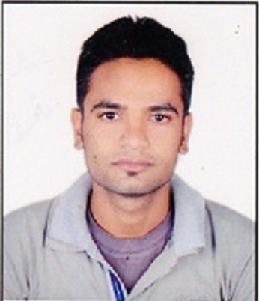
PUSHPENDRA KUMAR KUSHWAHA

Mobile no.: 8349739696, 6263288383

E-mail : pushpendrakushwaha.me10@gmail.com
Address : Village - Bhaiswar Post - Bhaiswar
Dist.- Satna, Madhya Pradesh
Pin No. - 485666
Objective
To be a part of an organization where process of learning & growth never ends & where I can get opportunities to utilize my knowledge and skills and keep on adding to the organization I represent.

Profile Snapshot

- A career focused individual, with Diploma/Degree (Mechanical) from Rajiv Gandhi Proudyogiki Vishwavidyalaya Bhopal, Madhya Pradesh.
- A confident and fast learner with strong communication skills.

Education

- MBA (Plain), Awadhesh Pratap Singh University, Rewa (M.P.)
2018-2020, Aggregate (CGPA) 6.45.
- Bachelor of Engineering (Mechanical Engineering), Rajiv Gandhi Proudyogiki Vishwavidyalaya Bhopal (M.P.)
2014-2017, Aggregate (CGPA) 7.04
- Diploma (Mechanical Engineering), Rajiv Gandhi Proudyogiki Vishwavidyalaya Bhopal M.P.
2013, 1st Division (77.67%)
- 12th Standard, M.P. Board of Secondary Education
2014, 2 th Division (57.00%)
- 10th Standard, M.P. Board of Secondary Education
2010, 1st Division (81.16%)

Computer Skills
- Software
Proficient: Internet Explorer for Education, E-Mail

Major Project

Project Title: JOB CUTTER (Bachelor of Engineering)

- Main aim of the project will be to design for Cutting and holding, All type of Job (Metallic and Non-Metallic). Using links, Pair, Hexa blade, holding device, Feed weight, Capacitor, Step down Transformer Etc. We can cut the Job in easy way.

Project Title: DOMESTIC LIGHT THROUGHT SOLAR PANNEL (Diploma Engineering)

- Main aim of the project will be to design a solar domestic light that will entirely from the power of the sun. This is obtained from solar panels on the surface of the roof. Photovoltaic (PV) cells convert the sun’s energy directly into electric energy.

Vocational / Industrial Training

- Industrial Training from 09.07.2016 to 30.07.2016 in Universal Cable Limited. (Bachelor of Engineering)
- 15 days vocational training in TATA Motors. (Diploma Engineering)

Personal Details

- Name : Pushpendra Kumar Kushwaha
- Marital Status : Single
- Father’s Name : Mr. Ramkesh Kushwaha
- Mother’s Name : Mrs. Susheela Kushwaha
- Date of Birth : 25th July 1994
- Nationality : Indian
- Language Known : Hindi & English
- Hobbies : Listening to Music & Playing Cricket

Personal Characteristics

- Hard working, enduring long hours under pressure.
- Taking tasks and completion on time & Reliable and flexible.
- Enjoy working in team & Able to learn new concepts quickly.

Declaration

I hereby declare that above mentioned details are correct and complete to the best of my knowledge. If you find my resume up to your expectations, I will surely expect a position for myself in your organization.

Date: 14.05.2021
Place: Satna (Pushpendra Kumar Kushwaha)

