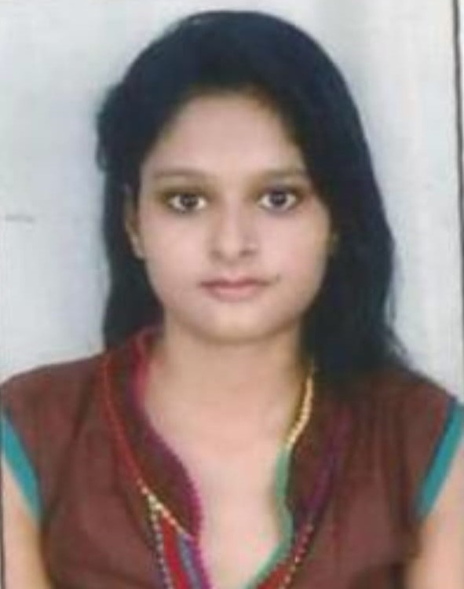**CURRICULUM - VITAE**

**SHIPRA SHUKLA**

**Mobile: 8318690666**

**E-Mail:** **shiprashukla288@gmail.com**

**Career Objective**

To associate with vibrant organization which allows me to put my competencies to the best use and add value to the organization contributing to growth as an individual.

**Career Summary**

Three years of work experience in the field of HR which includes recruitment, Compensation, Training & Development, Induction, HR Policies and process, MIS Reports. Seeking a respective position in the field of HR and to use my skills and knowledge for company growth.

**Professional Summary : (Total Exp. – 3 years)**

|  |  |  |  |
| --- | --- | --- | --- |
| **Company** | **Duration** | **Total Time** | **Role** |
| SHASHANK MEDI PHARMA Pvt Ltd  (lucknow) | NOV’19 – **Till Now** | - | HR Excutive |
| DNM Infra Pvt Ltd  (kanpur) | MAR’16 – JUN’18 | 2 Year 3 Months | EA to MD & Assistant executive –HR & Admin |

**Roles & Responsibilities:**

* Sourcing and selecting the candidate.
* Maintain all kind of candidate data base.
* Update MIS report on weekly basis.
* Support HR in scheduling and conducting performance appraisal meeting with various department.
* To ensure that attendance system are followed and salary of employees administered timely.
* Negotiating and amicable settling of issues among the staff rising due to policies, Time office and salary & wages administration matters.
* Counseling/Mentoring of the employees to maintain a healthy work environment and facilitating.
* Conducting Talent Management project for various institutes.
* Other Admit Activities like printing & stationary, handling office expanses , Co-ordinate with companies, Business development activities
* Working in PF and ESCI portals

**PROFESSIONAL TRAINNING & INDUSTRIAL VISITS**

* **Professional Training:-** project report on payroll & compensation

**Company Profile :** RSPL Group is more than 5800 crore diversified conglomerate, which is committed to value for money propositions & credited with several innovations over last 3 decades. The sagacity to weave its business around consumer needs has conferred RSPL Group with a distinct value and identity.

**Company** : RSPL Limited

**Industry** : FMCG

**Project title :** THE STUDY OF PAYROLL PROCESS

* **Industrial visit:-**
* Industrial Visit of Katyayni Paper Mills.
* Industrial Visit of Hindustan Unilever Ltd.
* Industrial Visit of Amit packaging, Sumerpur (Third Party Plant of Hindustan Unilever Ltd).

**Achievements:**

* Secured third position in Cam-Fest (Documentary), organized by management department of MPGI 2018.
* Secured first position in AD-MAD (comedy advertisement),organized by management department of MPGI 2019
* Secured second position in Cam-Fest (Documentary), organized by management department of MPGI 2019.
* Secured third position in ARGURBLY THE BEST (Debate), organized by management department of MPGI 2019.
* Participate as a coordinator in START-UP (New idea of business), organized by management by department of MPGI 2019.
* Secured second position in FASHION CHOREOGRAPHY, AKTU FEST (ZONAL LEVEL) Organized by MPGI

**Computer Skills**

* Computer Course Concepts (CCC) Completed from NEELIT.
* Good Knowledge of MS Office.
* Working Knowledge of Time, Attendance & Payroll Software.

**Educational Qualification:**

|  |  |  |  |  |
| --- | --- | --- | --- | --- |
| **Qualifications** | **Specialization** | **Year** | **Board/University** | **Percentage** |
| MBA | HR & MARKETING | 2020 | MPGI/AKTU | 67% |
| B.Sc | Science | 2015 | CSJMU University | 55% |
| 12th | Science | 2012 | U.P. Board | 52.2% |
| 10th | Science | 2010 | U.P. Board | 62% |

**Personal Details:**

|  |  |
| --- | --- |
| Father’s Name | Gopal krishna shukla |
| Date of Birth | 5th oct 1994 |
| Current Address | 117/559 p-1 block shivpuri ,kakadev Kanpur (U.P.) 208025 |
| Permanent Location | 117/559 p-1 block shivpuri ,kakadev Kanpur (U.P.) 208025 |
| Languages Known | English & Hindi |
| Marital Status | Single |
| Nationality | Indian |
| Current CTC | 1.80 Lac/Annum |
| Expected CTC | Negotiable |
| Notice Period | Immediately |

**Declaration :**

I consider myself familiar with management aspects. I am also confident of my ability to work in a team. I hereby declare that the information furnished above is true to the best of my knowledge.

Date: **Shipra Shukla**

Place: Kanpur (U.P.)