# SATYAM VERMA

CURRICULUM VITAE

## E- Mail ID :Satyamv329gmail.com Contact : 8299322659,8726334456

**Address** : **538ka 456/59 Triveninagar 3rd Shri puramSitapur road Lucknow**

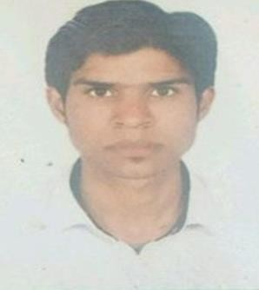**CAREEROBJECTIVE:**To beassociated with a progressive organization which can provide me with a dynamic work sphere to extract my inherent skills as a Marketing Professional, use and

develop my aptitude to further the organization’s objectives and also attain my career target in

the progress.

**EDUCATION / ACADEMICS:**

|  |  |  |
| --- | --- | --- |
| **Qualification** | **University/Board** | **Year Of Passing** |
| B.COM | LUCKNOW UNIVERSITY | 2016 |
| 12th | U.P. BOARD | 2012 |
| 10th | U.P. BOARD | 2010 |

**COMPUTER PROFICIENCY:**

MS –Office

**ACADEMIC ACHIEVEMENTS**

Played cricket at school level.

Organizing member of my school and college cultural committee.

**INTEREST**

* Listening Music, Travelling, Painting

**WORK EXPERIENCE:**

Organization**: HIVELOOP TECHNOLOGY PVT LTD (UDAAN)**

Tenure : **Jun’19-till present**

Role : Sales Executive (supply team) Lucknow,Kanpur,Gorkhpur

Accountabilities : Conducted the following duties

* + To look after whole Lucknow, kanpur business and Grokhpur..
  + Had to travel different places for market promote category..
  + Build and grow the marketfor supply
  + Grab the best deals
  + POC of Distributors or super stockiest for each and everything

Organization :**EUREKA FORBES LTD,** Tenure : Jan 14 – Dec 16

Role : Marketing Activator , sales, & GR leader. Accountabilities : Conducted the following duties

* To look after whole Lucknow business .
* Had to travel different places for market activities.
* Handled team of each business partner.
* Did cooperate/society/govt. offices.
* Looking after the branding of each business partners for visibility.
* To come up with new market idea for maximum lead generation.
* To look after score of each business in per cycle.

Organization: **AO SMITH INDIA PVT LTD,** Tenure : Jan 17-May 19

Role : Marketing Activator , sales ,supervisor Accountabilities : Conducted the following duties

* To look after whole Lucknow business .
* Had to travel different places for market activities.
* Handled team of each business partner.
* Looking after the branding of each business partners for visibility.
* To look after score of each business in per cycle.

## PERSONAL INFORMATION:

NAME : SATYAM VERMA DATE OF BIRTH : 01 MARCH 1995

FATHER NAME : MR. AYODHAYA PRASAD VERMA

E. MAIL : [Satyamv329@gmail.com](mailto:Satyamv329@gmail.com)

**SATYAM VERMA**