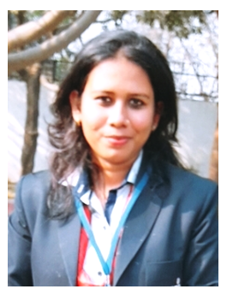
Deepali Saxena

DEEPALI SAXENA Contact address

mb17deepali.s@invertisuniversityac.in Deepali Saxena D/o Girish Kumar Saxena
(+91) 7505239944 787, Mall Godown road Civil Line
Budaun (Uttar Pradesh)

CAREER PROFILE_
Objective

To work with an organization offering challenging work profile and conducive work environment, where my skills knowledge can be utilized and honed, so can contribute to organizational and personal growth.

PROFESSIONAL QUALIFICATION _

I have done MBA in HR & MARKETING in INVERTIS UNIVERSITY Bareilly.

I have done BBA in BIMT College Budaun.

ACADEMICS _

- 12th Completed U.P. Board, Allahabad.
- 10th Completed U.P. Board, Allahabad.

SUMMER TRAINING _

I have done as a HR Recruiter training in Aflac Tourism Services Pvt .ltd from 45 days in Noida.

I have role attract employees who fit a job description and have the potential to become valuable additions to the company.

PROJECT UNDERTAKEN_

I have work with Recruitment and placement project.

In this project I have to understand the recruitment process and how the job is delegating the able person.

SKILLS _

- Strong motivational and leadership skills

- Exceptional presentation and interpersonal skills

- Unmatchable communication skill in writing and verbal both

- Ability to work in a team as well as individual

PERSONAL DETAILS_

- Father’s Name Mr. Girish Kumar Saxena
- Date of Birth 24 Oct. 1996
- Sex Female
- Religion Hindu
- Nationality Indian
- Martial Status Unmarried
- Language Known English, Hindi
- Permanent Address 787, Mal Godown road, Civil Lines Budaun
Contact (hometown) - (+91 )9719256361

HOBBIES AND INTEREST_

- Surfing and browsing internet.
- Interest Cocking & dancing.

Declaration:

- The above statements are true to the best knowledge and belief.

- Date…………………
(Deepali Saxena)
- Place………………...

