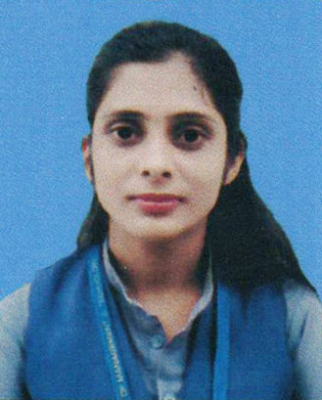
CURRICULUM VITAE
ANURADHA SINGH
Address:
Vill.-Pratappur
Post-Mirzamurad
Distt.-Varanasi-221307
Email ID: anusinghvns1@gmail.com
Mobile No: (+91) 8853777056

CAREER OBJECTIVE:
- Looking for career in an organization where I can put in my best efforts to enhance my technical and professional horizon in order to play a vital role for the betterment of the organization.
Experience:
- Working since 10 months in IGT Solution Pvt. Ltd. Gurgaon, Haryana in Air India customer service process.
PROFESSIONAL QUALIFICATION:
- Completed MBA with specialization H.R. (Major) & Marketing (Minor) from Rajarshi School of Management and Technology, UP College Campus-Varanasi (2020).
- Completed Bachelor of Business Administration (BBA) from Rajarshi School of Management and Technology, Varanasi (MGKVP, Varanasi) in the year 2018.
EDUCATIONAL QUALIFICATION:
- 12th from Kisan Inter College, Varanasi (U.P. Board) in the year 2015.
- 10th from Kisan Inter College, Varanasi (U.P. Board) in the year 2013.
TECHNICAL QUALIFICATION:
- 6 Months Course D.C.A.
INTERNSHIP DETAILS:
COMPANY NAME | : | NILGIRI INFRACITY PVT. LTD. MALDAHIYA, VARANASI
DURATION | : | 27 JUNE 2019 TO 14 AUGUST 2019
INTERNSHIP TOPIC | : | PROMOTIONAL STRATEGIES OF NILGIRI INFRACITY PVT. LTD.
EXTRA CURICULAR ACTIVITIES:
- Attended Workshop On Recent Trends In Banking Sector (RSMT-Varanasi).
- Certificate of National Seminar RAM-TECH in 2019
- Participated in Advertisement event in Inter College Competition Sijian-4 held in Rajarshi School of Management and Technology, UP College Campus-Varanasi.
STRENGTH:
- Self-Motivator
- Hard Work
- Quick Learner

PERSONAL DETAILS:
Father's Name : Mr. Pradeep Singh
Mother's Name : Mrs. Kusum Singh
Date of Birth : 16.10.1997
Gender : Female
Marital Status : Unmarried
Nationality : Indian
Language Known : English & Hindi

Date:
Place: (Anuradha Singh)

